**Assignment 1**

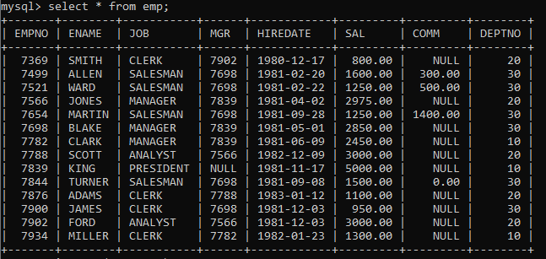

1. To list all records with sal > 2000 and comm>200

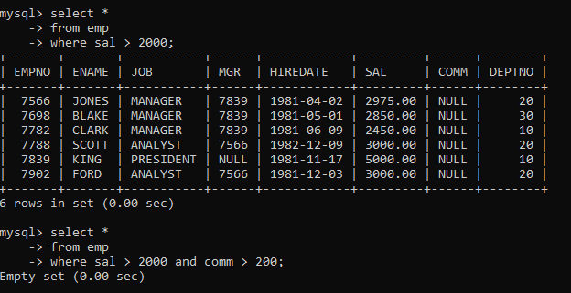

2. To list all record with job=’Clerk’ or sal>2000

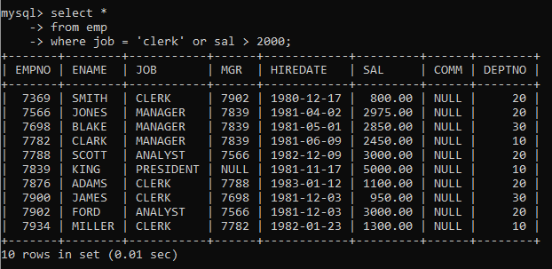

3. To list all the record with sal=1250 or 1100 or 2850

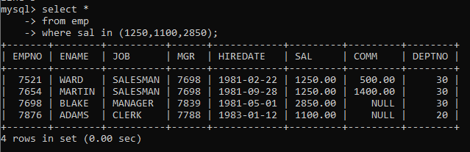

4. To list all employees with sal>1250 and <2850

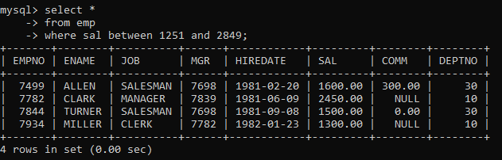

5. To list all employees with name ends with AS

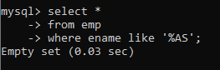

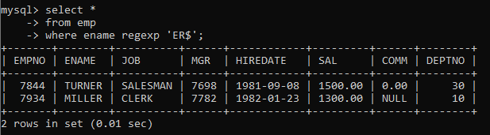

6. To list all employees with job starts with C and ends with K

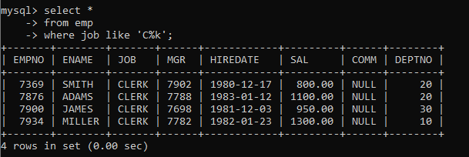

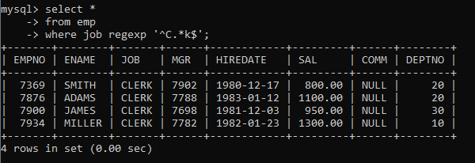

7. To list all employees with job contains L at third position and M at third last position

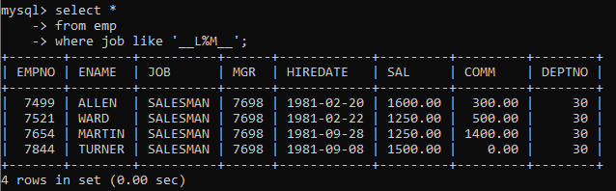

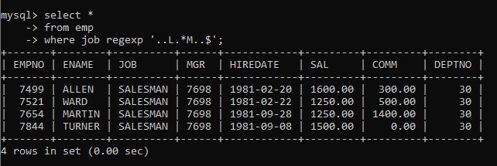

8. To list all the record with sal not equal to 1250 or 1100 or 2850

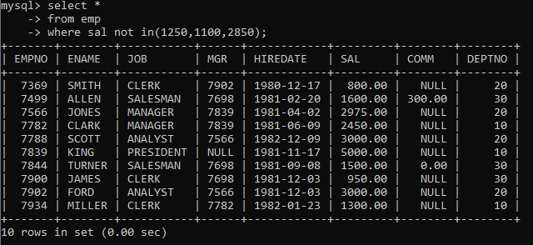

9. To list all employees with salnot >1250 and <2850

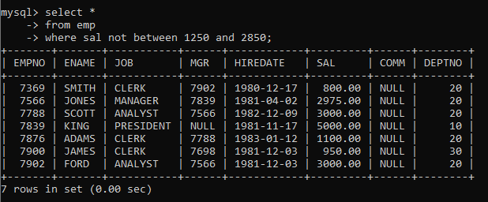

10. To list all employees with job starts with C , E at 3rd position and ends with K

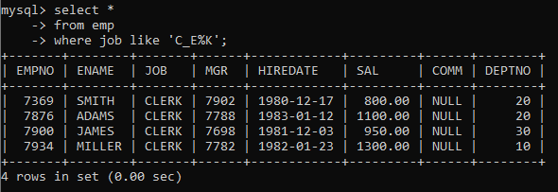

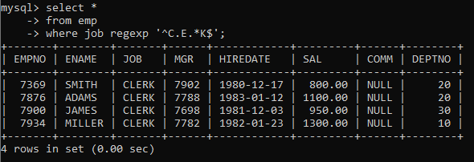

11. To list all rows with comm is null

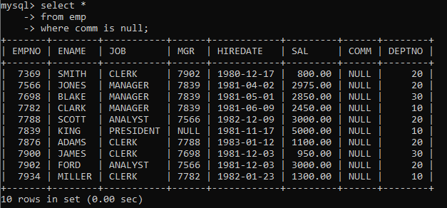

12. To list all employees with sal is null and name starts with ‘S’

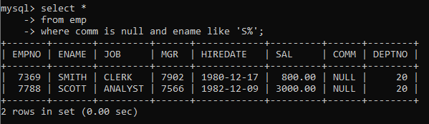

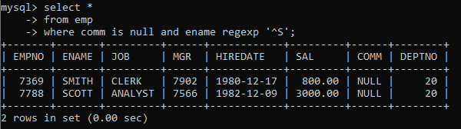

13. To list all employees with job contains 5 characters

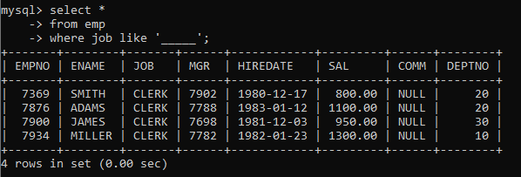

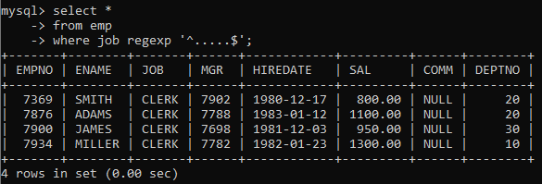

14. To list all employees with name contain ‘A’ at 1 position and job. Contains 5 characters.

